2019-2024 National Outer Continental Shelf Oil and Gas Leasing Program
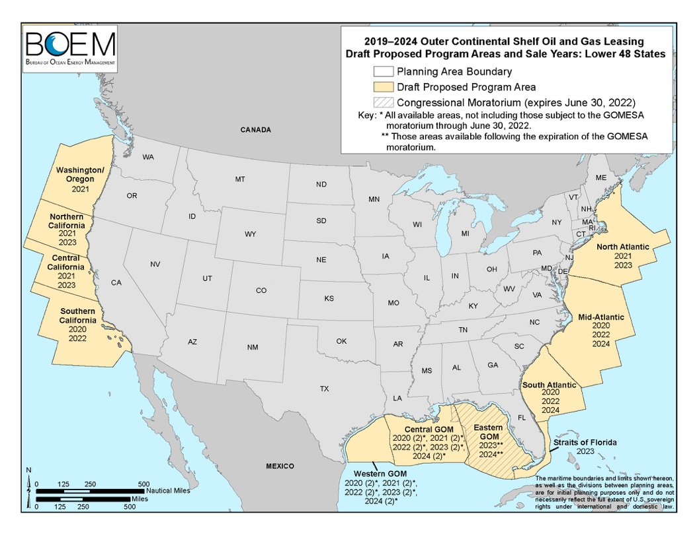
Atlantic Could Open for Oil and Gas Development
The Bureau of Ocean Energy Management (BOEM) has proposed opening the Atlantic coast and other coastal areas for oil and natural gas development in their draft 2019-2024 National Outer Continental Shelf (OCS) Oil and Gas Leasing Program (see areas shaded in yellow).

Opening the Atlantic OCS would strengthen America’s role as a global energy superpower by injecting more domestic energy into our economy. Although we need to develop all forms of energy, the government projects that we will still need oil and natural gas for decades to come, even with renewables.

BOEM National OCS Program Process
BOEM develops the OCS Oil and Gas Leasing Program (National OCS Program) for oil and gas development in accordance with the Outer Continental Shelf Lands Act (OCS Lands Act). This National OCS Program establishes a five-year schedule of oil and gas lease sales proposed for the U.S. OCS. The National OCS Program specifies the size, timing, and location of potential leasing activity that the Secretary of the Interior determines will best meet national energy needs for the five-year period under consideration.

Currently, BOEM is working under the approved 2017–2022 Program. However, as directed in Executive Order 13795 (April 28, 2017) and Secretary's Order 3350 (May 1, 2017), BOEM is initiating a process to develop a new National OCS Program for 2019–2024 that, if approved, will supersede the 2017–2022 Program. BOEM is currently taking Public Comments until March 9, 2018 on the 2019–2024 Draft Proposed Program (DPP).

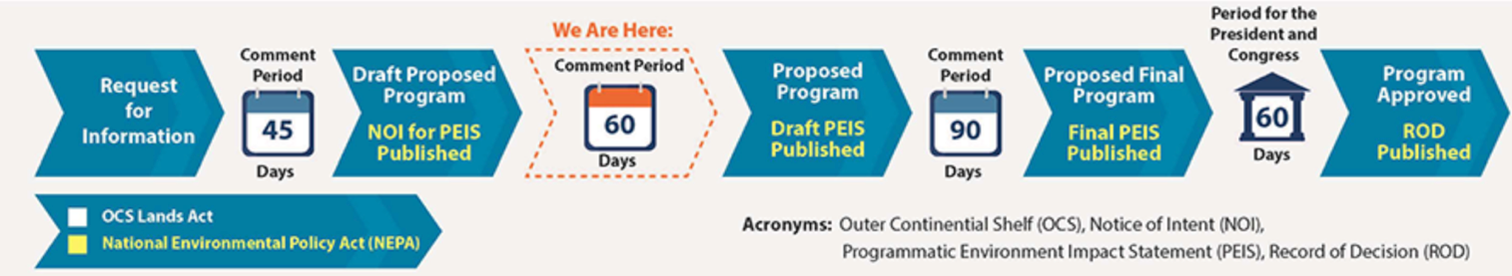

Source: BOEM: “Developing a National OCS Program”
Public Comments:

Due date to BOEM: March 9, 2018 11:59 PM Eastern Time

Address Comment to:
Ms. Kelly Hammerle
Bureau of Ocean Energy Management
45600 Woodland Road
Sterling, VA 20166

To submit Online Comments:
- Go to: https://www.regulations.gov/comment?D=BOEM-2017-0074-0001 or http://bit.ly/2Fq4Al3
- Follow instructions on page to complete comment.

Additional Information
2019-2024 National Outer Continental Shelf Oil and Gas Leasing Program
For additional information regarding the 2019-2024 National Outer Continental Shelf Oil and Gas Leasing Program:
https://www.boem.gov/National-Program/

America’s Offshore Energy Potential
For additional information regarding America’s offshore natural gas and oil potential, go to:

http://www.americasoffshoreenergy.com/

